BUSINESS INTELLIGENCE LAB
EXPERIMENT 5
Report Generation using Relational and Multidimensional Data on the Star Schema using Power BI

1. Aim
To generate relational and multidimensional reports on the star schema built in Experiment 3 and extended in Experiment 4, using Table and Matrix visuals, the Geo_Hierarchy, comparative charts, and an interactive dashboard in Microsoft Power BI to support business decision-making.

2. Learning Objectives
- Understand the difference between transaction-level relational reporting and summarized multidimensional reporting.
- Reuse the existing star-schema data model and geographic hierarchy from Experiment 4.
- Apply sorting, visual-level filtering, aggregation, drill-down, and drill-up in Power BI.
- Compare sales and profit across product categories, regions, customers, and years.
- Combine important performance indicators and slicers into an interactive dashboard.

3. Software and Requirements
- Microsoft Power BI Desktop.
- The completed Experiment 4 Power BI (.pbix) report based on the Global Superstore dataset.
- Fact_Sales as the fact table and Dim_Customer, Dim_Product, Dim_Region, and Dim_Date as dimension tables.
- The Geo_Hierarchy in the order Region → State → City.
- Existing measures such as Total Sales and Total Profit, where available, and an appropriate Total Orders measure.

4. Introduction / Theory
Business intelligence reporting converts operational data into information that can be used to monitor performance and make decisions. In Power BI, a report can present detailed rows, summarized values, visual comparisons, and interactive filters over the same underlying data model.
A relational report presents records at transaction level. Each row represents a record from the sales data, enriched with descriptive attributes such as customer, product, and region. Sorting and filtering help users find particular transactions or focus on profitable records.
A multidimensional report groups measures across dimensions. In this experiment, the geographic hierarchy Region → State → City is used to summarize Total Sales, Total Profit, and Quantity. Drill-down reveals a more detailed level, while drill-up returns to a summary level.
Comparative charts present patterns that may be difficult to see in a long table. A category chart compares product groups, a regional chart compares profit, a Top 10 chart ranks customers by sales, and a yearly line chart displays changes over time. A dashboard combines selected key indicators and visuals with slicers to make exploration easier.

5. Part 1: Reopen and Verify the Model
The Experiment 4 PBIX report was reopened and saved as a separate Experiment 5 copy so the original file remained unchanged. In Model view, the relationships from Fact_Sales to Dim_Customer, Dim_Product, Dim_Region, and Dim_Date were checked. Each relationship should be many-to-one from the fact table to its corresponding dimension table.
The Geo_Hierarchy was checked to confirm the level order Region → State → City. The existing Slice, Dice, and Drill pages were retained. Each page was opened to check that its visuals showed values rather than blanks.

Observation
Reusing the existing model avoids rebuilding the relationships and hierarchy. It also allows the new reports to be compared with the OLAP analysis completed in Experiment 4.

6. Part 2: Relational Report
A new page named Relational Report was created and a Table visual was inserted. The following fields were added in the required order:
- Order ID from Fact_Sales
- Customer Name from Dim_Customer
- Product Name from Dim_Product
- Region from Dim_Region
- Sales from Fact_Sales
- Profit from Fact_Sales
The Sales column was sorted in descending order so that the largest sales values appeared first. A visual-level filter was added to Profit and configured as is greater than 0. This filter limits the displayed table to profitable transactions.
The visual's Export data option was used to save the displayed rows for further inspection. Depending on the Power BI version and export settings, the available format may be Excel or CSV.

Observation
The relational report displays individual transaction details and allows a user to identify the order, customer, product, region, sales value, and profit associated with each displayed record. The exact row count after filtering, the first customer, and the first product should be recorded from the live Power BI report.

Business Use
This report is useful when an operations or sales team needs to inspect a particular transaction, investigate profitable orders, or verify customer and product details. It is less suited to seeing broad patterns across many categories because it lists individual records.

7. Part 3: Multidimensional Report
A new page named Matrix Report was created with a Matrix visual. Geo_Hierarchy from Dim_Region was placed in Rows. Total Sales and Total Profit were placed in Values, along with Quantity from Fact_Sales using Sum aggregation.
The hierarchy supports geographical analysis at three levels. At Region level, the matrix gives a broad comparison. Expanding a region reveals its states; expanding a state reveals its cities. Drill-up returns from City to State and then to Region.

Observation
The matrix summarizes the same underlying sales data at different geographic levels. The City-level figures should be compared with the corresponding state and city view on the Experiment 4 Drill page. If both visuals use the same data, measures, and filter context, the corresponding values should agree.

Business Use
A regional manager can use this view to identify where sales and profit are concentrated, then drill into a state or city to investigate local performance. The hierarchical view reduces the need to inspect every transaction individually.

8. Part 4: Comparative Analysis Report
A page named Comparative Analysis was created to show four views of business performance. Existing charts from earlier experiments may be reused if their fields and calculations are correct.

8.1 Sales by Category
Category from Dim_Product is placed on the axis and Total Sales is placed in Values. This chart compares sales contribution across product categories.

8.2 Profit by Region
Region from Dim_Region is placed on the axis and Total Profit is placed in Values. This chart compares profitability by geographic region. Profit should be used rather than Sales so that the chart answers the intended question.

8.3 Top 10 Customers by Sales
Customer Name is placed on the axis and Total Sales is placed in Values. In the visual-level filter for Customer Name, the filter type is changed to Top N, Top is set to 10, and Total Sales is entered in By value. Apply filter is selected. The chart is sorted by Total Sales in descending order.

8.4 Sales Trend by Year
Year from Dim_Date is placed on the X-axis and Total Sales is placed on the Y-axis of a line chart. The visual shows how sales change from one year to another in the available dataset.

Observation
Together, the four visuals provide category comparison, regional profit comparison, customer ranking, and a time-based trend. Unlike the relational table, these charts summarize many transactions and make differences or patterns easier to identify. Specific leading categories, regions, customers, and yearly movements must be described using the actual visual results.

Business Use
These visuals can support product planning, regional performance review, customer relationship management, and trend monitoring. They provide a quick comparative view before a manager investigates individual records in the relational report.

9. Part 5: Interactive Dashboard
The Dashboard page combines KPI cards, charts, and slicers. The required cards display Total Sales, Total Profit, and Total Orders. The slicers use Region, Category, and Year.
The cards should use existing measures where possible. If a Total Orders measure is needed, it should count distinct order identifiers using the actual order ID field in the model. Charts from Comparative Analysis can be copied to the dashboard and arranged below the KPI cards and slicers.
The interactions must be tested. Selecting a region, category, or year should filter the relevant visuals. If a visual does not respond, Edit interactions can be used to confirm that the slicer is configured to filter that visual rather than having no interaction.

Observation
The dashboard brings key indicators into one view and enables users to explore a selected region, category, or year without manually editing each chart.

Business Use
The dashboard is suitable for a high-level management review, where the user needs a quick overview of sales, profit, and order volume and then wants to narrow the view using slicers.

10. Summary Table
Report Type | Fields / Measures | Key Observation | Business Use
Relational Report | Order ID, Customer Name, Product Name, Region, Sales, Profit | Shows individual records sorted by Sales and filtered to Profit > 0. | Investigating specific orders and profitable transactions.
Multidimensional Report | Geo_Hierarchy, Total Sales, Total Profit, Quantity | Summarizes results at Region, State, and City levels. | Comparing geographic performance.
Comparative Analysis | Category, Region, Customer Name, Year, Total Sales, Total Profit | Compares categories, regions, customers, and yearly sales. | Identifying differences and trends.
Dashboard | Total Sales, Total Profit, Total Orders, Region, Category, Year | Combines KPI cards, charts, and interactive slicers. | Monitoring performance for management reviews.

11. Interpretation: Dashboard vs. Relational Report
A regional manager would use the Dashboard to review overall performance through KPI cards, charts, and filters for Region, Category, and Year. The Relational Report is used to inspect individual transactions, customers, products, sales amounts, and profits. Therefore, the Dashboard supports high-level decision-making, while the Relational Report supports detailed transaction-level investigation.

12. Result
The Experiment 5 report workflow extends the existing star-schema model with relational, multidimensional, and comparative reporting. The Table visual supports transaction-level analysis, the Matrix visual supports geographic drill-down and drill-up, comparative charts summarize category, region, customer, and yearly performance, and an interactive dashboard brings key measures together for business decision-making.

13. Conclusion
This experiment demonstrates that the same business dataset can be presented at different levels of detail in Power BI. Relational reporting supports inspection of individual transactions, multidimensional reporting supports hierarchical geographic analysis, comparative charts highlight differences and trends, and an interactive dashboard supports ongoing performance monitoring.

14. Submission Checklist
- Confirm the four relationships in Model view and verify Geo_Hierarchy as Region → State → City.
- Check the Relational Report fields, descending Sales sort, Profit > 0 filter, and exported file.
- Record the actual remaining row count, top customer, and top product.
- Test Matrix drill-down and drill-up and compare a state/city with Experiment 4.
- Check that all four Comparative Analysis charts have the required titles and fields.
- Test Region, Category, and Year slicers against the dashboard visuals.
- Insert screenshots of the completed Power BI pages if required by the instructor.
- Replace general observation statements with the actual results shown in Power BI.

Appendix A: Illustrative Visual Layouts
The following images are illustrative layout guides, not screenshots of the user's live Power BI report. Replace or supplement them with actual screenshots after completing the visuals in Power BI.
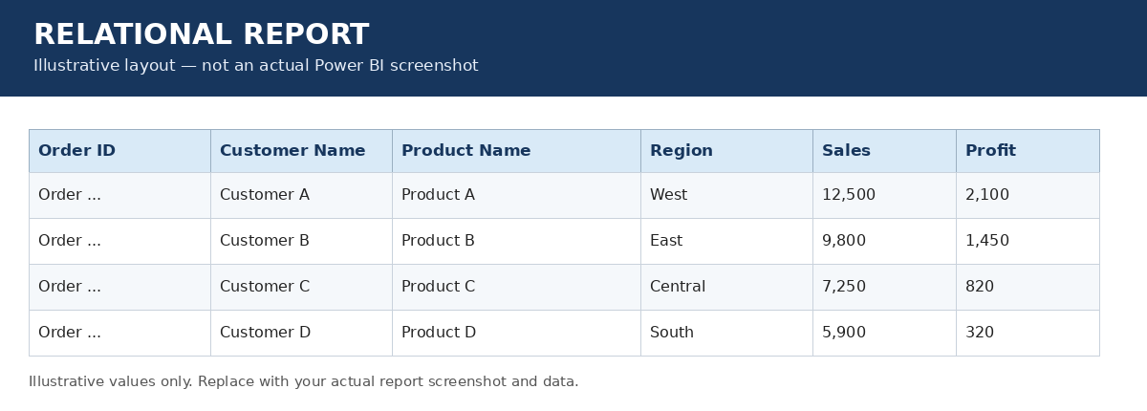
Figure A1. Example structure of the Relational Report table. Sample values are illustrative only.
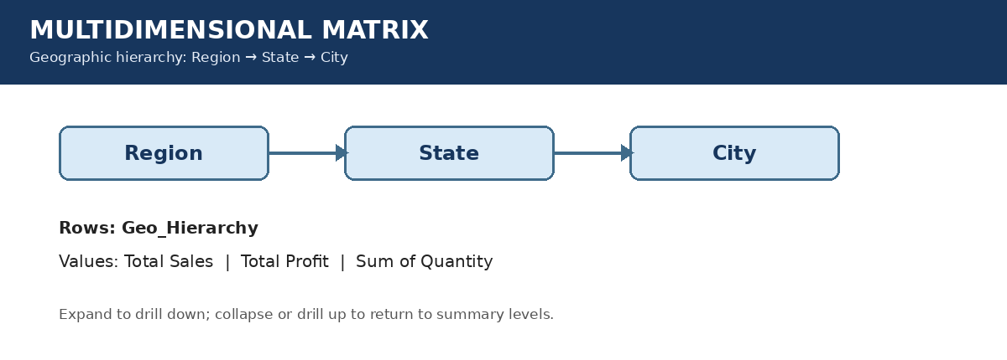
Figure A2. Geo_Hierarchy structure used in the Matrix Report.
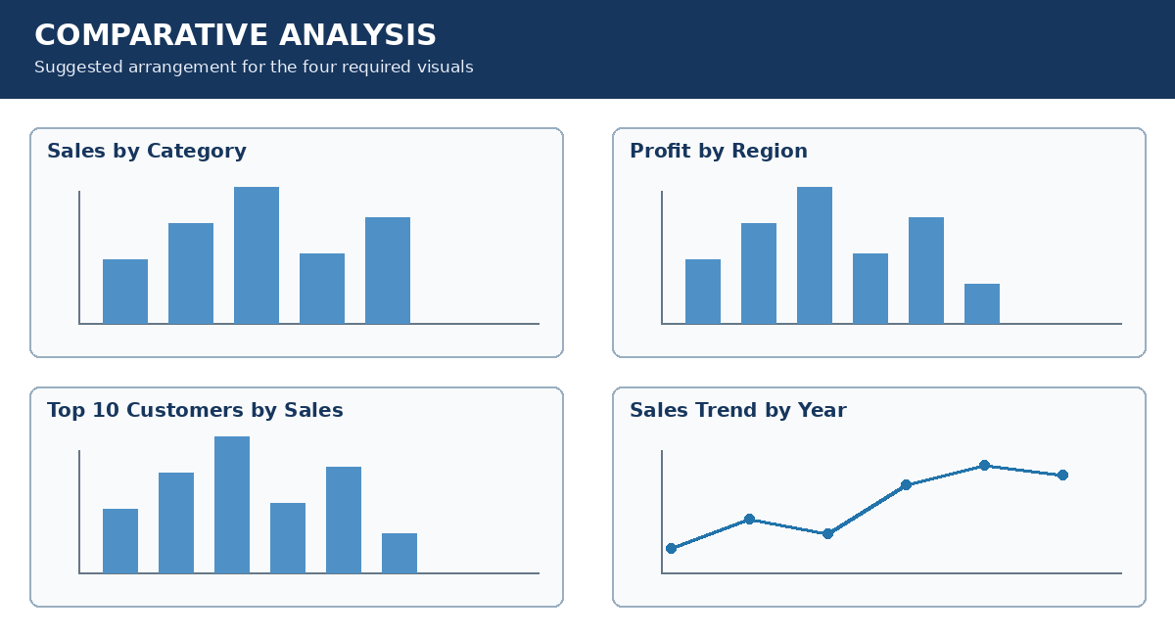
Figure A3. Suggested four-visual layout for Comparative Analysis.
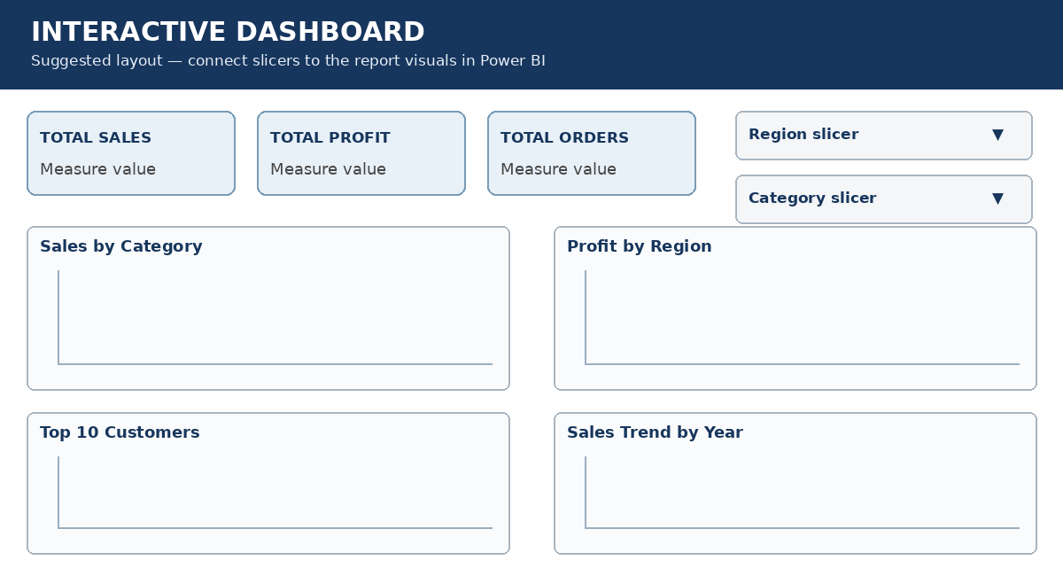
Figure A4. Suggested layout for the interactive Dashboard.

